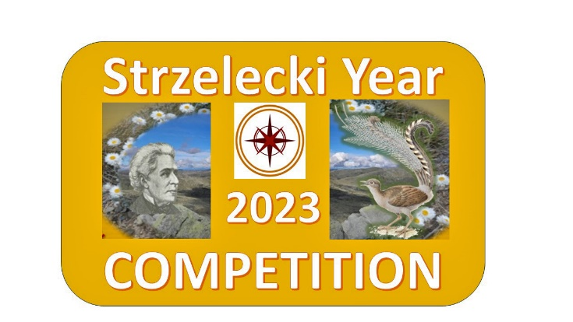

2023 STRZELECKI YEAR
INTERNATIONAL COMPETITION

A Tribute to Strzelecki the Explorer, Scientist and Humanitarian

ENTRY FORM

Name:
Email address:
Home address:
Telephone number:
Date of birth:
Name of school (if applicable):
School address (if applicable):
Entry title:

Entrant’s Statement: I declare that the entry I am submitting to 2023 Strzelecki Year International Competition is my own work.

Signature:
Please sign by hand, or insert image of signature, into the field above.

Date:

Please note:
- Entries must be received no later than midnight (Australian Eastern Standard Time) on July 20th, 2023.
- All entries become the property of the Kosciuszko Heritage Inc.
- Entries must be sent to competition@kosciuszkoheritage.com

